Back-End Processing

Web framework

We will focus on Applicating code using Ruby language based on rails web framework

Rails uses a Model View Controller (MVC) structure

Models -> Logic and data (Business logic and data structure, for ex: users, products, shopping cards)

Views -> HTML fragments (Dynamic fragments of HTML)

Controllers -> coordinating models and views

Router -> rules for handling URIs





How these three Parts interact

Using new Rails command

> rails generate controller to start building dynamic pages

Controllers, Views and Models and Routers

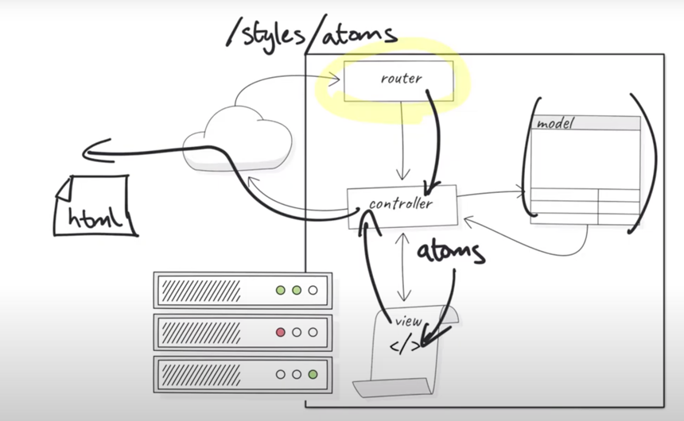

Router determines styles controller.

Controller determines atoms action for the view

View determines the atoms html to send to controller

Controller renders the atoms html to the web browser through the internet